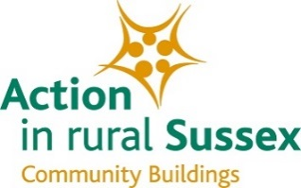

PAT TESTING TRAINING WORKSHOPS 2017 - BOOKING FORM

I / we would like to attend the following PAT Testing Training Workshops:

Tick as appropriate

Wednesday 20 September 2017 Sussex House, Lewes ……………

Thursday 21 September 2017 Pulborough Village Hall ……………

Delegate One:

Name:

Organisation:

Job Title

Email:

Telephone Number:

Delegate Two:

Name:

Organisation:

Job Title

Email:

Telephone Number:

Invoice Address:

An invoice will be sent to you via email address given above.
Payment must be received prior to the workshop in order to confirm your booking.
Please return this form to villagehalls@ruralsussex.org.uk

