Sample social media posts for Village Halls Week 2026
If you need some inspiration for what to post on social media during the week, you can use the sample posts below as a starting point. Please adapt them as you see fit to make them relevant to your hall and activities. If you’re able to generally match your posts with the themes of each day, that would be great, but there are no strict rules. The main aim is to spread the word about all the fabulous things happening in village halls across Sussex, so please do make it relevant to your circumstances.
To download the image for each day, click on the pictures and that should open a window for you to save it.
If you tag us (‘mention us’) and/or use the hashtags, listed with the posts, it means we will be able to see and re-post your posts for increased reach.

Monday 16 March – Connecting
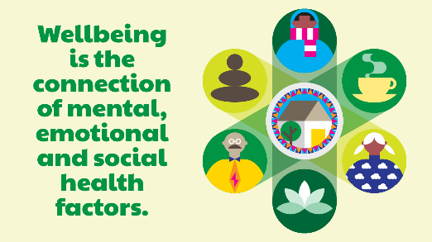
🏡 It's Village Halls Week 2026! This year's theme is Connecting Communities to Health and Wellbeing — and what better way to kick things off than by celebrating the power of connection.
Whether it's a friendly face at a community café, a chat after a lunch club, or making new friends at a youth group, [HALL NAME] is a place where everyone belongs.
Feeling connected to others is one of the most important things we can do for our mental health. That's why your village hall matters.
Who have you met here that's made a difference to your life? Tell us in the comments 💬
#VillageHallsWeek #ConnectingCommunities #VillageHall #SussexCommunity #MentalWellbeing #Connect

Tuesday 17 March – Being active
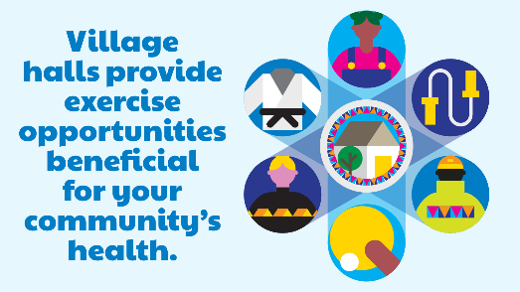
🏃‍♀️ Day 2 of Village Halls Week and we're celebrating movement!
From exercise classes and dance to sport and chair-based yoga, [HALL NAME] offers so many ways to get your body moving — whatever your age or ability.
Being active boosts your mood, reduces stress and helps you sleep better. And doing it with others makes it even better.
What's your favourite way to get active at [HALL NAME]? 👇
#VillageHallsWeek #BeActive #VillageHall #SussexCommunity #PhysicalHealth #ActiveCommunities

Wednesday 18 March – Keep learning
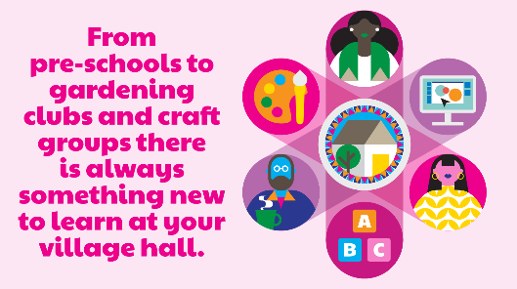
📚 Halfway through Village Halls Week — and today we're celebrating lifelong learning!
From pre-schools taking their very first steps, to language classes, art workshops and everything in between, [HALL NAME] is a place where curiosity is always welcome.
Learning something new builds confidence, keeps our minds sharp and gives us a real sense of achievement. And it's never too late to start.
What's something you've learnt — or would love to learn — at [HALL NAME]? Let us know 👇
#VillageHallsWeek #KeepLearning #VillageHall #SussexCommunity #LifelongLearning #NeverStopLearning

Thursday 19 March – Giving
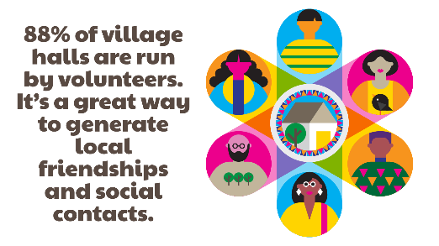
🙌 Today during Village Halls Week we're shining a light on the incredible volunteers who make it all possible.
Did you know that 88% of village halls across the country are run entirely by volunteers? At [HALL NAME], it's the dedication of our trustees and volunteers that keeps the doors open and the community thriving.
Volunteering is a brilliant way to meet people, build friendships and know you're making a real difference.
Fancy getting involved? Get in touch — we'd love to hear from you. And if you already volunteer here, we couldn't do it without you. Thank you 💛
#VillageHallsWeek #Volunteering #GiveBack #VillageHall #SussexCommunity #CommunityHeroes

Friday 20 March – Taking notice
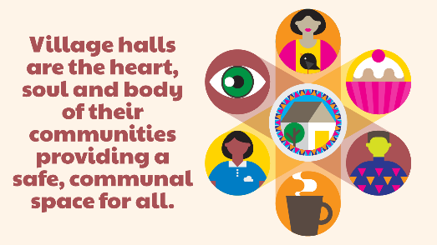
🌿 It's the final day of Village Halls Week and we're ending on a moment of calm.
In the rush of everyday life, it can be hard to slow down. But taking notice — of the world around you, of how you're feeling, of the people you're with — is one of the most powerful things you can do for your wellbeing.
[HALL NAME] is a place to pause. Whether it's a mindfulness class, a meditation session, a yoga class, or simply a quiet moment in our outdoor space, we're here to help you reconnect with what matters.
Take a breath. You've got this 🌸
What does taking notice mean to you? Share your thoughts below 👇
#VillageHallsWeek #TakeNotice #Mindfulness #VillageHall #SussexCommunity #MentalHealth #Wellbeing

